Assignment 5

1 Write a query that will give you all orders for more than Rs. 1,000.

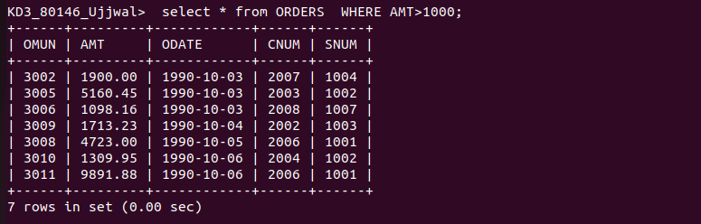

2 Write a query that will give you the names and cities of all salespeople in London with a commission above .10?

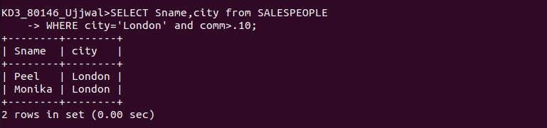

3 Write a query on the Customers table whose output will exclude all customers with a rating <= 100, unles they are located in Rome.?

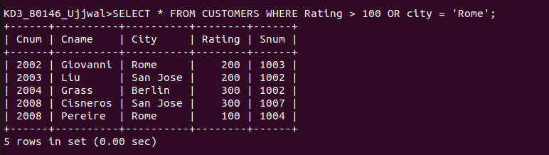

4
What will be the output from the following query?

Select * from Orders where (amt < 1000 OR NOT (odate = 1990-10-03/ AND enum > 2003));

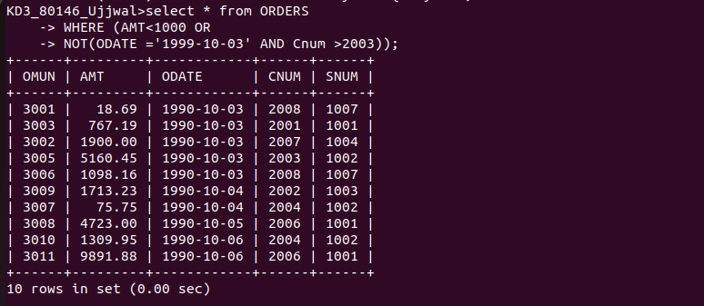

5
What will be the output from the following query?

Select from Orders where NOT ((odate = '1990-10-03 OR snum

>1006) AND amt >= 1500);

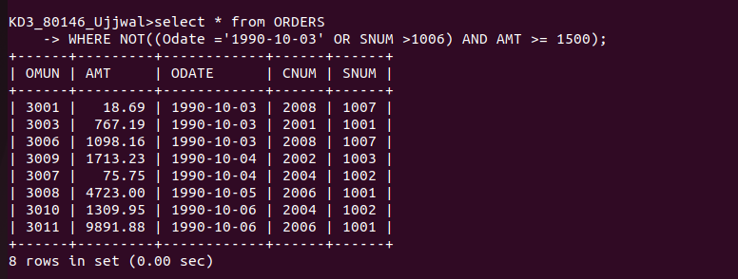

6 What will be the output from the following query?

Select snum, sname, city, comm From Salespeople
where (comm>.12 OR comm <.14);

